Shell commaonds

1.chmod

Wt is default permission of file and directory after creation ?

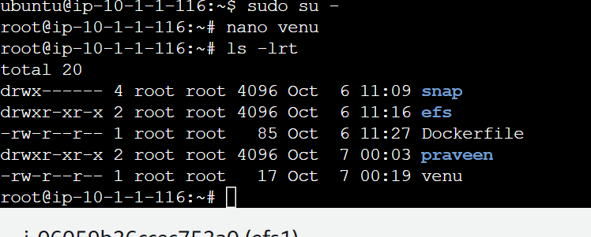

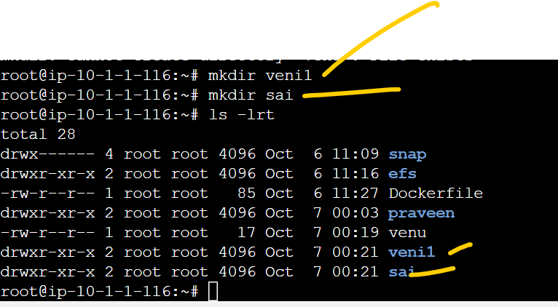

Simple for loop script:

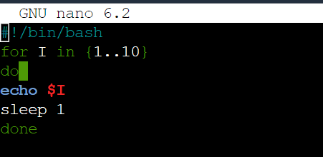

Exu:

Sleep using slowly excustion:

How to copy form one directory to another



s

===============how to declare the varible

Name=venu

Surname=Mahankali

Echo “my firstname Is $Name & my last is $Surname”

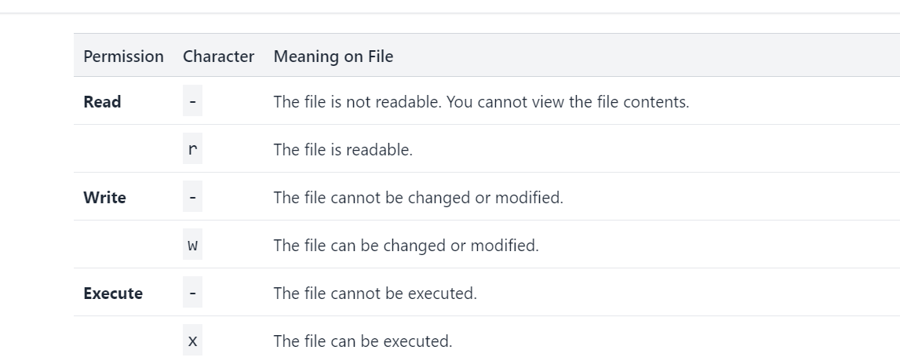

4 =r

2=w

1=excute

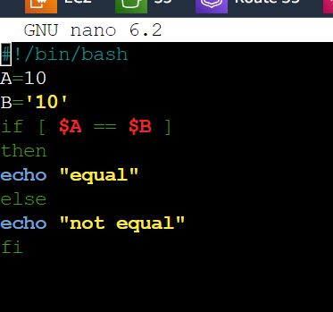

Simpe script by using string parameters

How to delcate the variables:

Declare the varible names

Give declare the variables value

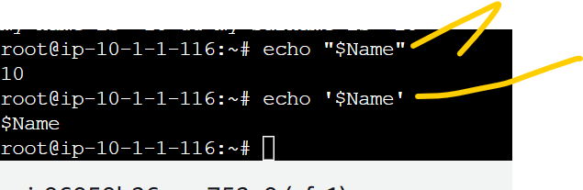

1If u provide the doubel quots it is act as it will substiture the value

1If u provide the single quots it is act as string as not substiture the value

<https://www.geeksforgeeks.org/string-operators-shell-script/>

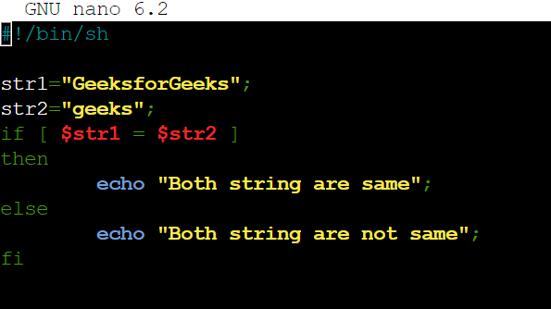

Not equl symbol

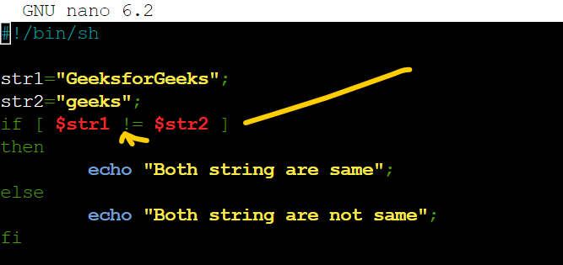

Step 3

-n string

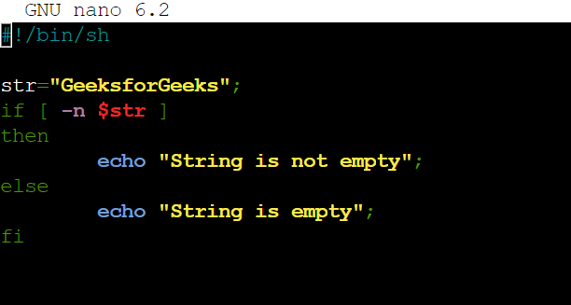

How to provide the list

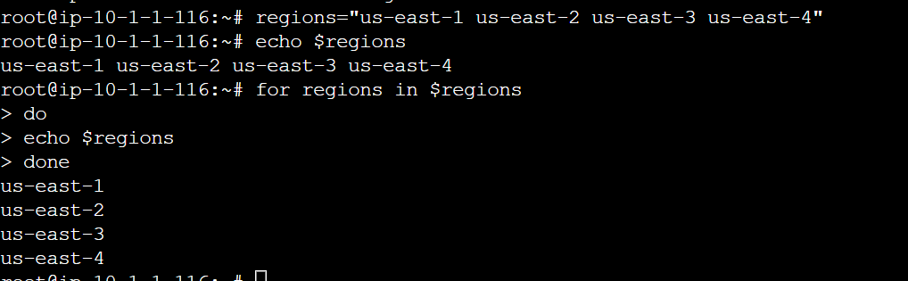

Wt are special typemof operators:

$? $\* $@ $#

$? Recent excute command successfully it is show 0

Below screeshot for example

$? Recent excute command not successfully it is show value except 0

Below screeshot for example

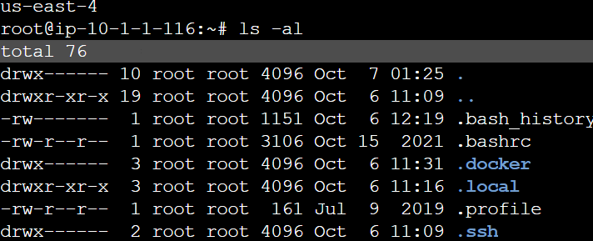

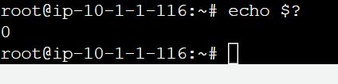

Not successful excute command

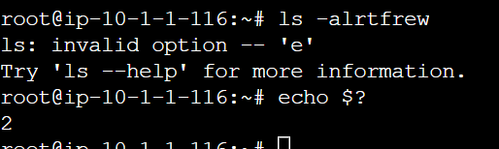

$@

Examples:

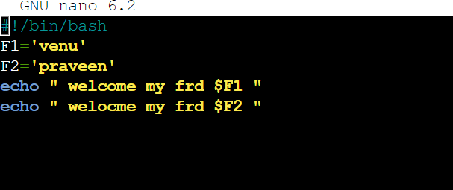

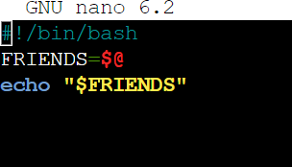

What are u give name will print

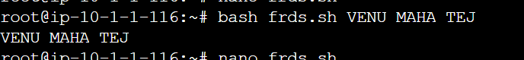

$\* same function

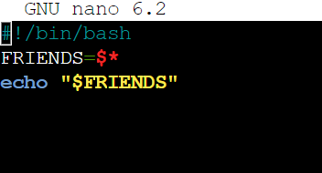

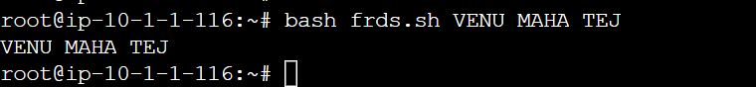

$\* vs $# diff



